Tower Hamlets Online Carers Self-Assessment Form
This document is intended to help you prepare answers for the second part of the online carers self-assessment form where free text answers are requested. You may wish to type your answers into this Word document and then copy and paste them into the online form. THIS WORD DOCUMENT IS NOT TO BE SUBMITTED.
If you require support, please contact the Carers Centre on 020 7790 1765 or by emailing enquiries@ccth.org.uk
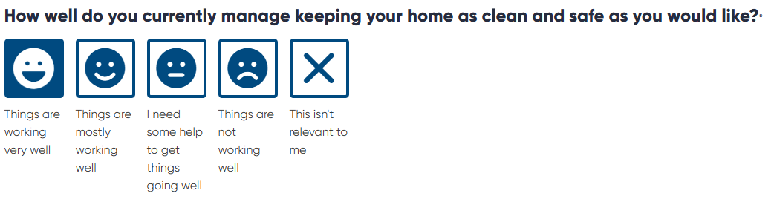
If you would like, please tell us more?
Please type or write further details in the space below. You can copy and paste them into the relevant section in the online form when you are ready.

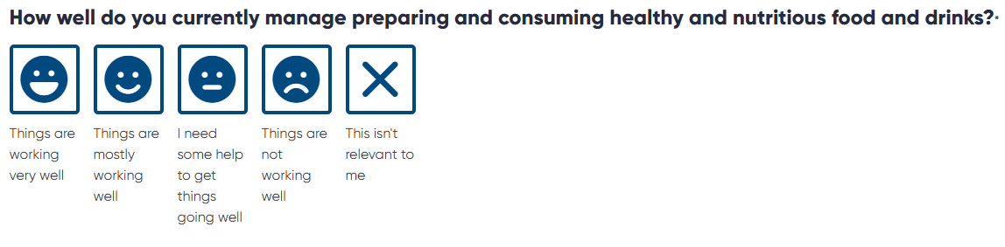
If you would like, please tell us more?
Please type further details in the space below. You can copy and paste them into the relevant section in the online form when you are ready.

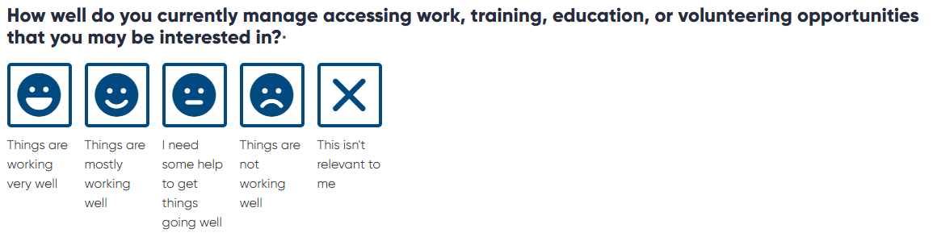
If you would like, please tell us more?
Please type further details in the space below. You can copy and paste them into the relevant section in the online form when you are ready.

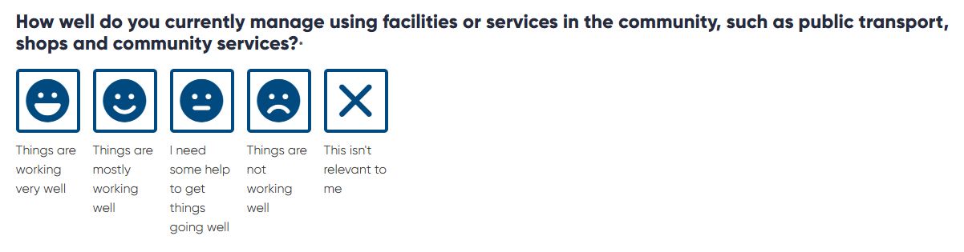
If you would like, please tell us more?
Please type further details in the space below. You can copy and paste them into the relevant section in the online form when you are ready.

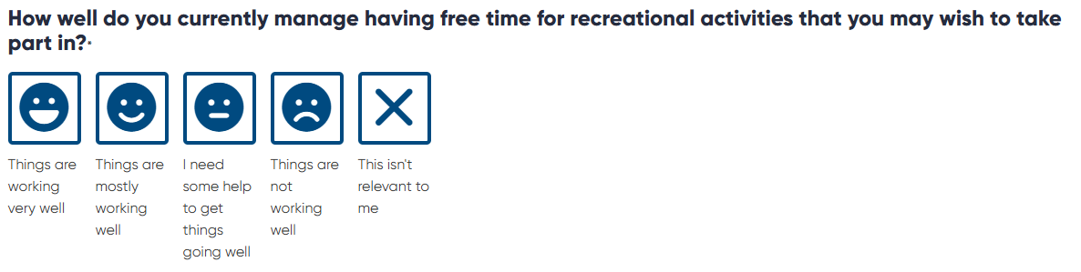
If you would like, please tell us more?
Please type further details in the space below. You can copy and paste them into the relevant section in the online form when you are ready.

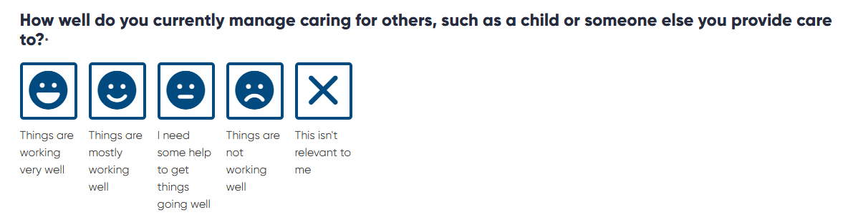
If you would like, please tell us more?
Please type further details in the space below. You can copy and paste them into the relevant section in the online form when you are ready.

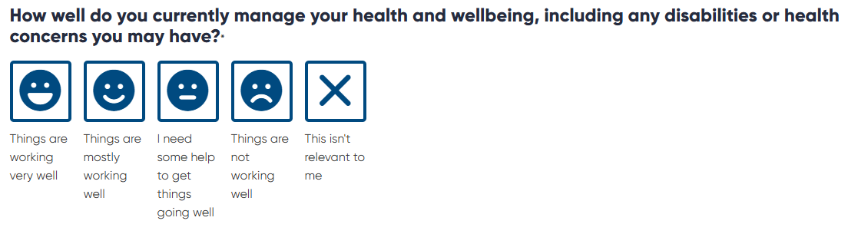
If you would like, please tell us more?
Please type further details in the space below. You can copy and paste them into the relevant section in the online form when you are ready.

